Assignment 1, A Gym Club Apk Layout Design

Use Case Scenario:

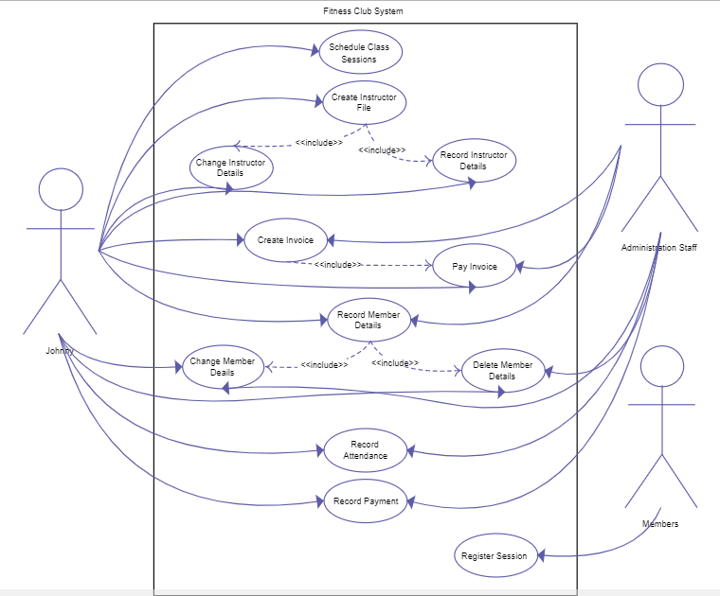

This semester’s assignments will focus on the gym club application system with use case scenarios demonstrated above.

In assigment 1, you are asked to develop the android UI layout for the gym club app.

Requirements:

1, Although it is not necessary to provide complete functioning UI, you need at least provide the dashboard UI plus UI for registering as club member, looking for and booking trainers and training classes, more features such as club news and activity posters, sign-up/sign-in are prefered.

2, Navigations through each screens and feature UIs are also highly recommended.

Delivery:

1, You need to archive the project and running screen video to a github or publicly available repository.

2, Providing a report of team members, technical features applied.

2, Hand in due to 2018 - 9 - 30